PROJECT REPORT
ON

MARBLE MAZE

Team Members

Name | E-mail | Contact no.
Gharat Apurva | apugha@gmail.com | 9867751766
Kulkarni Jyoti | jyoti.kulkarni23@gmail.com | 9930157041
Patil Supriya | supriya.patil337@gmail.com | 9029520337

Table of Contents

1. Introduction 3
2. Problem Statement 4
3. Requirements 5
4. Implementation 6
5. Discussion of System 7
6. Testing Strategy and Data 13
7. Future Work 15
8. Conclusion 16
9. References 17

1. Introduction:

Gaming is the act of playing a game. Gaming the system, a term for manipulating a system's rules to achieve a desired outcome.

Marble maze is a game in which you need to control a ball in a labyrinth by titling the device in your hands and leads the ball into goal.

Game is actually based on the classic game that many of us have played when we were little children where tiny ball have to make its way around the obstacles, through the maze, reaching the goal.

- Problem statement

Marble Maze is a board puzzle where the goal is to make a marble traverse through a maze from start to the end point. This project aims at robotic control for traversing of marble from a defined starting point to the ending point. This can be achieved using:
Image Processing System (Computer Controlled) or
Accelerometer (Person Controlled)
Player will be given two choices at the start of the game. If the player selects Image processing then there will not be any manual interaction between the game and player. Player can enjoy the solving of puzzle as any person enjoys the game of Cricket just watching it, though he or she is not actually playing the game.
If the player selects Accelerometer then user will interact with the game through the accelerometer. It is the same device which is used n mobile phones to play some mobile based games. As the user will move the accelerometer the maze will be moved accordingly and user himself will solve the puzzle.

- Requirements

A) Following are the hardware requirements for the project:
- ATMEGA 640 DEVELOPMENT BOARD: Microcontroller
- Accelerometer: To tilt the frames
- Servo Motor: To move the frames
- Web camera (iBall C12.0):To capture the image
- Maze: To make puzzle
- Marble: To solve puzzle
- Frames: To move the puzzle up ande down and hold it.
- Wooden Stand: To support the Frames and camera frame.

B) Following are the hardware requirements for the project:
- MATLAB: for image processing
- WinAvr: Compiler for the AVR
- AVR studio: To program instruction onto a given microcontroller
- AVR Boot loader: To Burn the program onto a microcontroller.

4 Implementation:

The following flow-chart explains the working principle:
START

SWITCH

Manual (Accelerometer)
Automatic (Image Processing)

Press the switch 1

Press the switch 2

Capture the image and send to PC
Move the accelerometer

Process in Matlab
Reach the goal.
Send the signal accordingly to microcontroller so that the maze will move
STOP

The steps can be enumerated as follows:
- First the user will press the switch1 or switch 2.
- If user presses switch1 then Image processing will be executed.
- Else if user presses switch 2 Accelerometer will be executed.
- For image processing, once the switch is pressed controller will be transferred to MATLAB program.
- There it will capture the image, finds the valid path and then gives command to microcontroller to move the servo motors accordingly.
- For accelerometer, once the switch is pressed controller will take ADC values for X and Y axis and convert it to digital values and then according to titling of accelerometer frames will be moved.

4.1 Assumptions and limitations

The following assumptions and limitations had to be taken into account:
- The communication of accelerometer is wired
- Also the camera connections are wired.
- Therefore distance limitations are there.
- Also for image processing it is always assumed that the marble is placed at starting point.
- Program for demo purpose is done in the static way.
- Light constraints are there for web camera to capture the image of maze.
- Not a bit handy hardware.

5. Discussion of System
Hardware Setup:
The project starts off without any builded robot. The designed hardware is own design especially for this game. The micro controller plays an important role in the project. Hardware consists of different frames, components such as web camera, maze, servo motors etc.

5.1 Structure of Frame
Metal Frame type: - Aluminum
Sr no. | Frame |  | Dimensions
1 | Outer Frame |  | 26 X 26 inch
2 | Middle Frame |  | 18 X 18 inch
3 | Inner Frame |  | 12 X 12 inch
4 | Frame Width |  | 1.5 inch
5 | Acrylic Sheet |  | 9 X 9 inch
6 | Servo box |  | 3 X 3 inch
7 | Camera Frame
 | 7.1 | Height | 25 inch
 | 7.2 | Length | 27 inch
8 | Frame Stand
 | 8.1 | Number of legs | 6
 | 8.2 | Height | 8 inch
 | 8.3 | Width | 1.5 inch
9 | Maze |  | 7.5 X 7.5 inch
10 | Microcontroller Board Box |  | 8 X 5.5 inch
Table 1.5.1

5.2 Steps for designing:-
- Aluminum frames are used because it is a light weight metal so that the metal servos can move it will be easily.
- We built 3 frames of increasing size inner frame, middle frame and outer frame respectively.
- Acrylic sheet is fitted in the inner metal frame for keeping maze on it.
- Stand is fitted on the outer frame. The height of the stand is kept 8 inches so that the tilted frames will not touch to the ground. And maze should not be unbalanced.
- We selected metal gear servo motors because plastic gear servo motors are too low powered to move the metal frames.
- First servo motor is fitted between inner frame and middle frame to move the inner frame up and down. The servo is fitted exactly at the center of both the frames so that balancing will be done properly and other sides of the frames are fitted with a light weight metal rod so that frames will move. Also the servo fitted is supported by acrylic sheet box.
- Similarly second servo motor is fitted between middle frame and outer frame to move the middle frame left and right. And both the middle frame and outer frame are joined by metal rod.
- Camera should be placed exactly above the maze. Therefore camera stand is fitted at the center of the outer frame from outside.
- For better connections we placed the microcontroller board at one side of outer frame from outside supported by an acrylic sheet.
- Web cam is fitted with the help of double sided tape at the center of camera frame.
- Finally the puzzle maze is placed at the center of acrylic sheet.

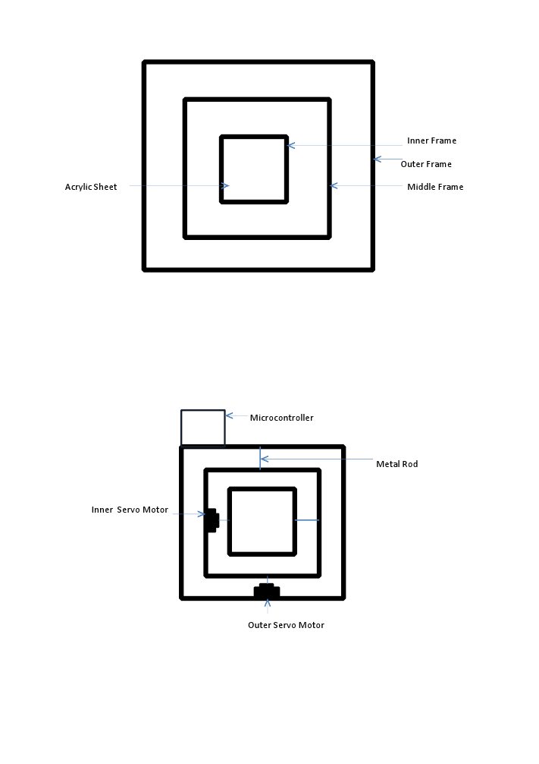

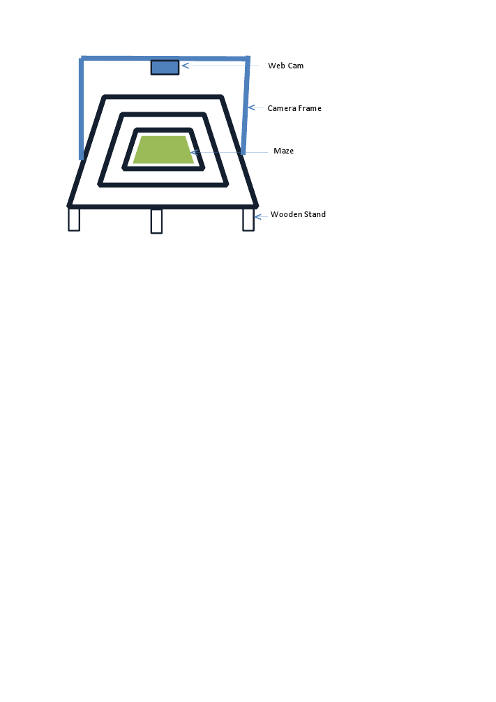

5.3 Project Status
Project time line
The project was started in the first week on Oct 2011 and finished till Apr 2012. The main development and coding required about 3 months with a team size of 3 members. Testing was simultaneously done. The final week was devoted to fine tuning of the project and documentation.

Critical steps in the project
Development of the hardware and the time associated with it was critical step. Coordinating the hardware was also a challenge.
Working with the MATLAB was also critical as it was found that they were unpredictable in their behavior and difficult to program.
Also the communication between MATLAB and microcontroller was a bit difficult task to achieve.

Individual roles and contributions
As the team size was small, at least any two of the three members always worked together. However, the work division was roughly done per member as

Member 1: Communication, Hardware, Coding.
Member 2: Hardware, Image processing, Communication, Coding,
Member 3: Coding, Documentation.

6. Testing
Testing was done in following steps:
- Servo motors:
For the servo motors first step is to align them at such an angle so that both the frames will be parallel to the ground at 90 degree of servo angle.
Then we noted some angle values for tilting of servo motors for left, right and up, down for outer and inner frames respectively.
After this we finalized the steady state angle values and tilting angle for both the servos.

- LCD:
For testing the LCD, we burned the program for it on microcontroller and executed.
Then values are displayed on the screen of LCD.

- ADC port:
To test the working of accelerometer we burned the ADC program on microcontroller and took the readings from LCD.
Then we calculated the average values for angle calculations of accelerometer and accordingly these values given to the servos.
After this we finalized some values for tilting of servo angles.

- Switch:
For switch we written the program and tested whether all the switches are working properly or not.
Then we finalized two switches, one for accelerometer and one for image processing.

- USB communication:
We first tested a small program which communicates with MATLAB and then written the actual code for communication between microcontroller and MATLAB.

- Web cam:
We connected the web cam to pc through USB cable. Then written some small codes in MATLAB for testing the camera

7. Future Work
The project has been developed keeping in mind that it can be further used as a game in gaming industry with some proper additions. This can be achieved by overcoming the existing shortcomings. Some of the extensions that can be incorporated are

- Using a wireless module such as Zigbee

- Different levels can be added

- Better and more compact structure

- Better image processing algorithms

The project definitely forms a platform for better work in the future.

8. Conclusion
The key areas that we gained knowledge in are

- Building an own hardware

- Interfacing with hardware

- Image processing

- USB communication

Overall the project has been very exciting and satisfying. The project in particular provided us with a better understanding and insight of actual problems faced in real life and the approach to their solutions.

Link to Project videos on Youtube.com
- http://www.youtube.com/watch?v=csnIYzeMmME
- http://www.youtube.com/watch?v=H43pj1CX9dc

9. References
1) Scarecrow Robot By E-Yantra Team : http://www.eyantra.
org/ci/projects/code/486
2) http://www.youtube.com/watch?v=78ucwJMDe7o From youtube
3) http://www.mathworks.in for Image processing.

